INSTRUCTIONS FOR OBTAINING SUPERTRACKER REPORTS

1. Go to the SuperTracker Website: https://www.supertracker.usda.gov (You can also access the SuperTracker website by going to http://ChooseMyPlate.gov. Click on the “Supertracker and Other Tools” tab at the top)

2. Create a Profile (Step 1). There’s a link in the top right-hand corner. Enter the requested information (age, height, weight, activity level, etc) for the person you’re doing a 24-Hour Recall for. You can skip Step 2 (Save Your Profile).

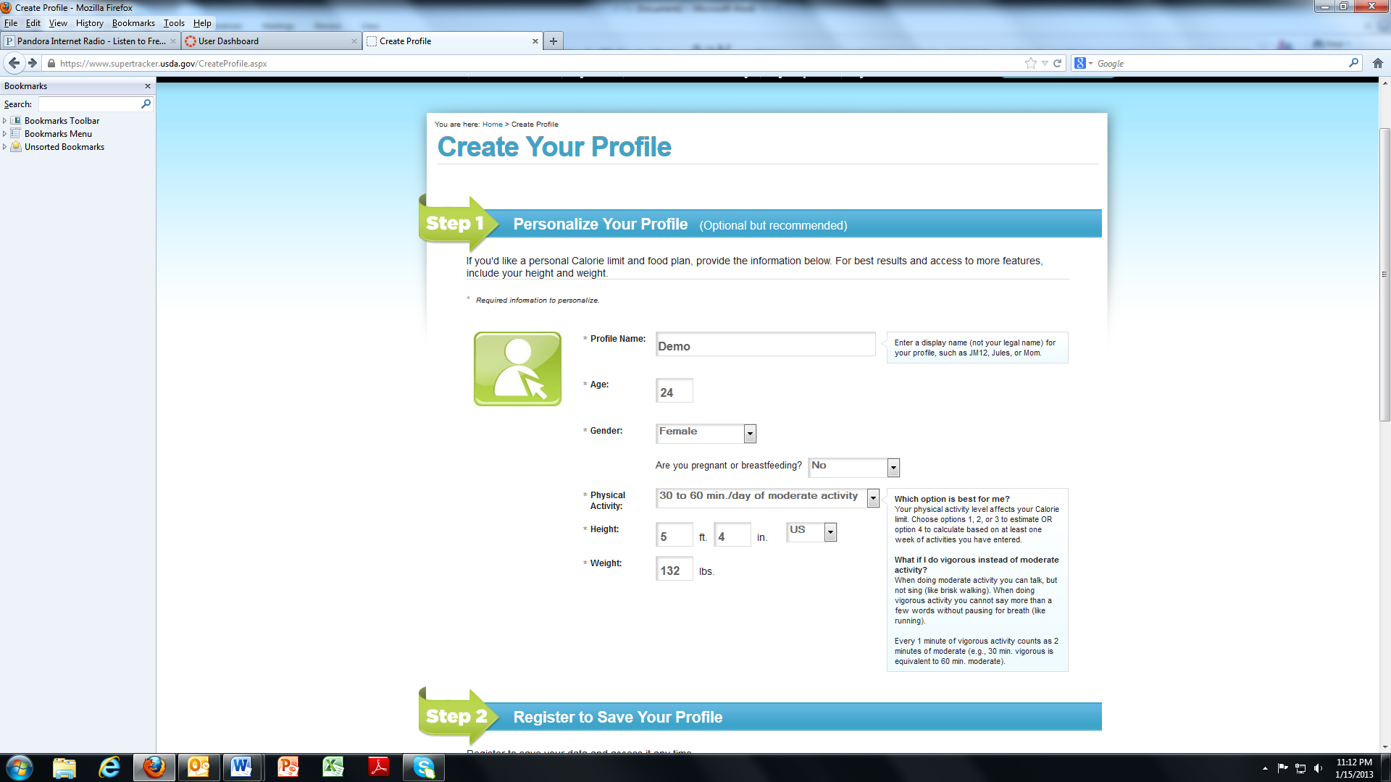

3. Scroll to the bottom of the screen and click on the “Submit” Button.

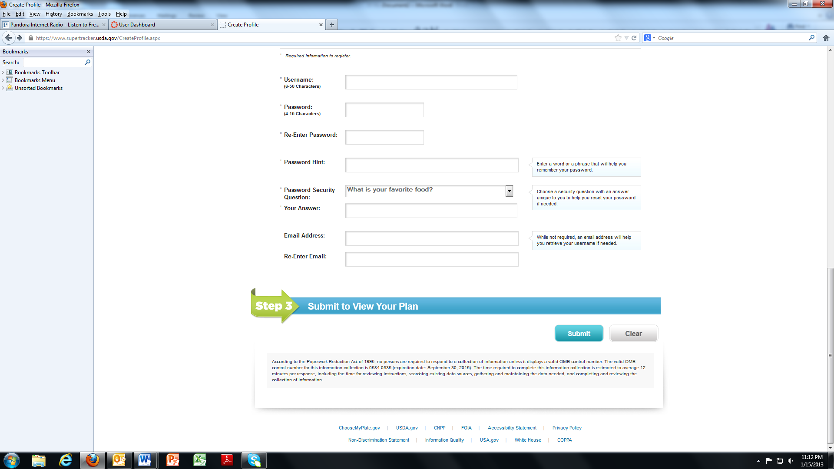

4. Enter foods from your written food record and choose the best match from the list of options that come up (you won’t always find an exact one).

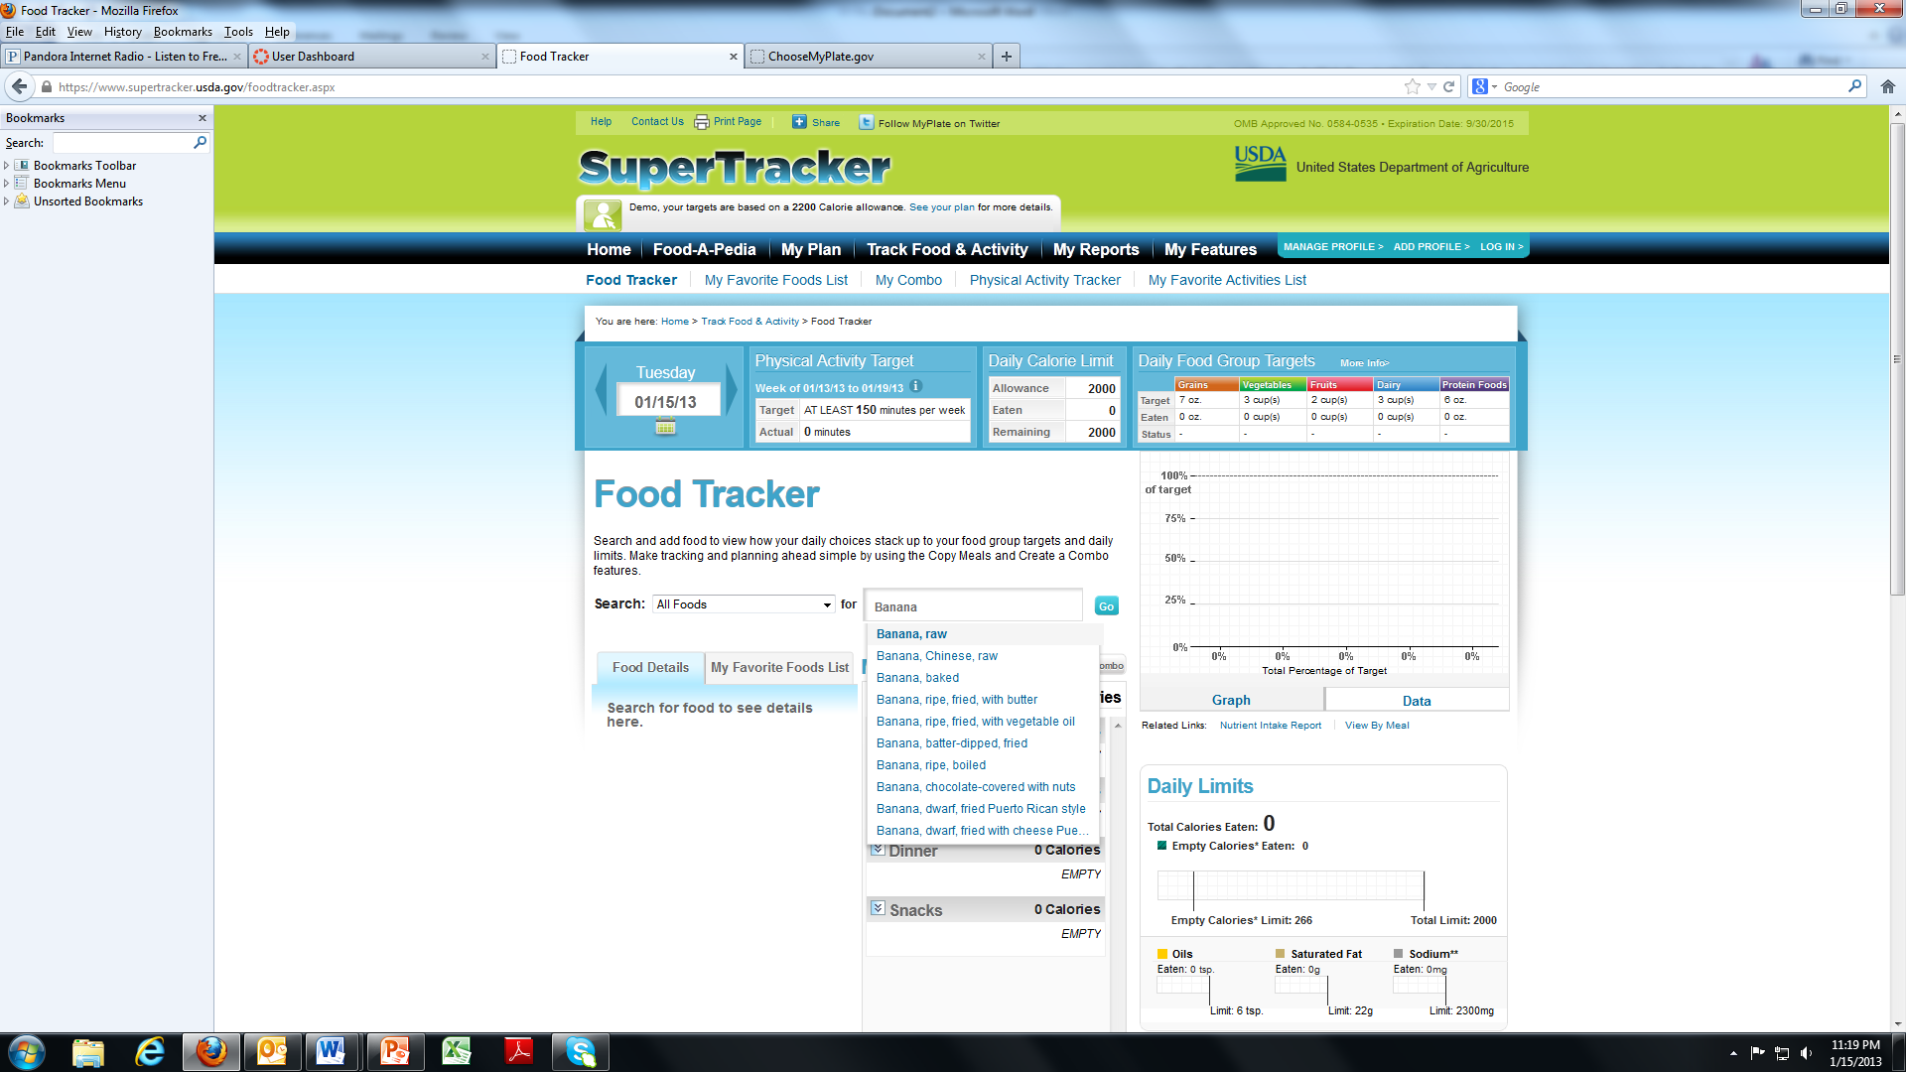

5. Enter the amount (serving size) and meal (breakfast, lunch, dinner, or snack). Click the “Add” button.

Do this for each food item. You can edit, remove, or add foods to a favorites list as needed.

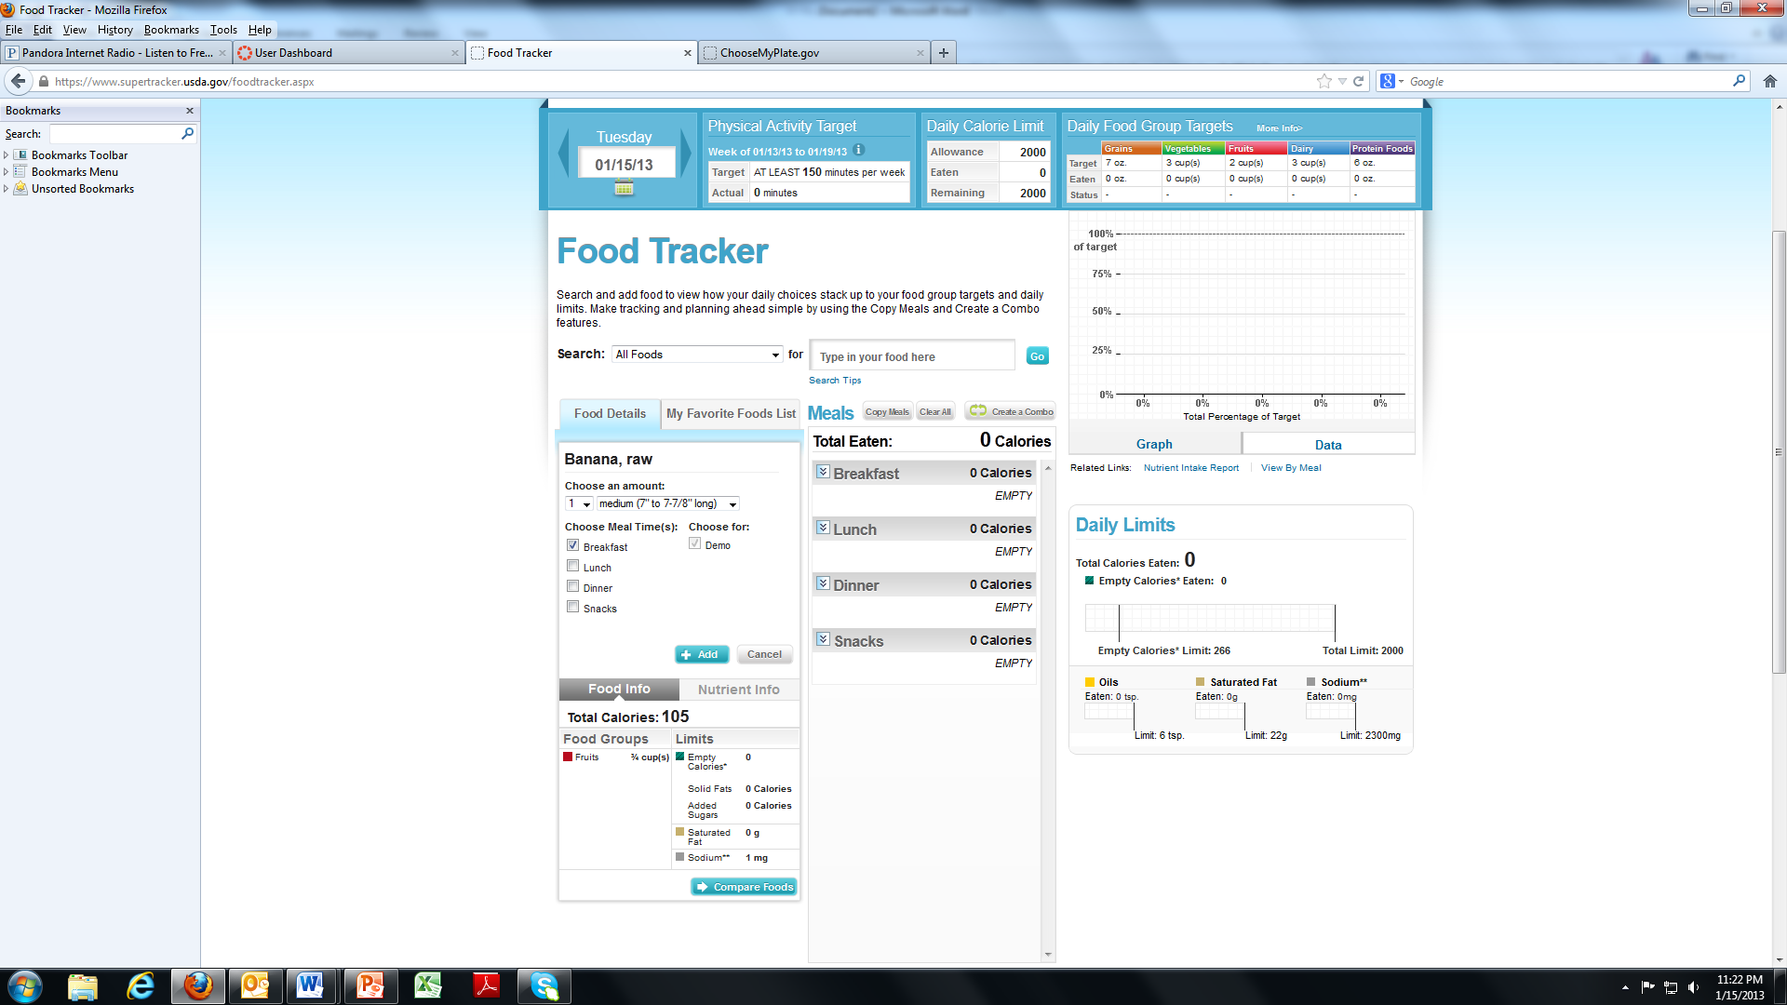

6. After you finish, double-check for mistakes before proceeding to “My Reports”. Make corrections if necessary. Click on the “My Reports” tab at the top.

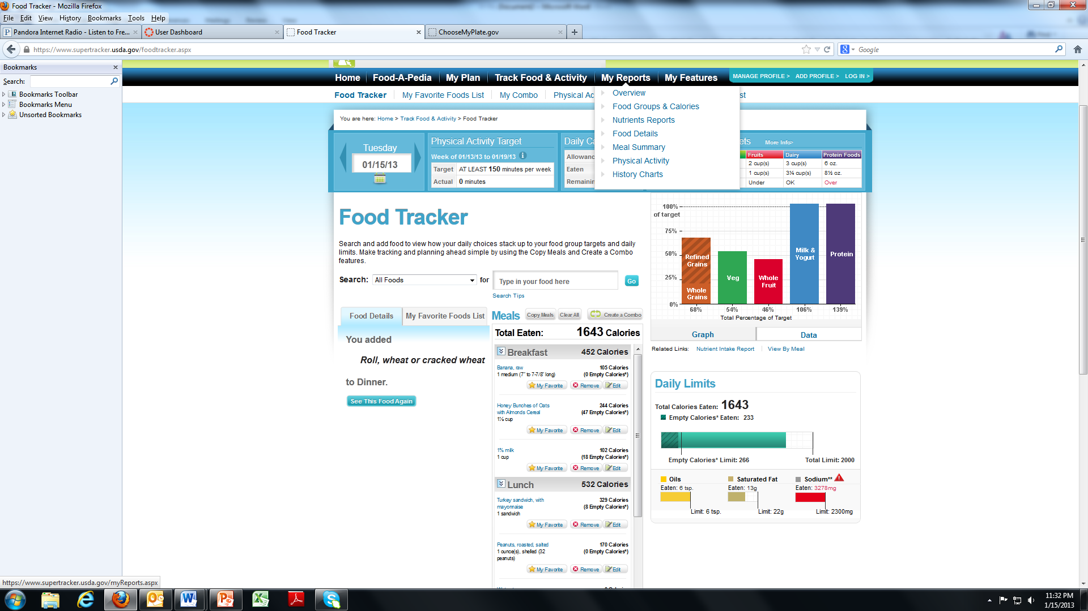

7. For the “Food Groups & Calories” Report, enter the date (same start and end date) and click on the “Create Report” Button. A preview of this report will appear on the screen.

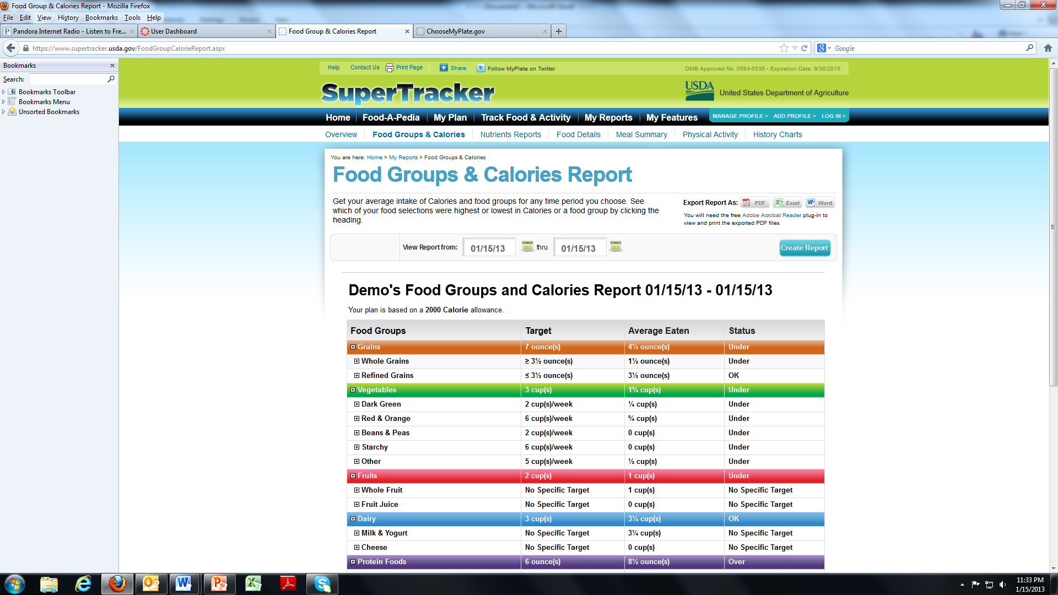

8. Download as a PDF Report (click on the “PDF” button in the top right corner) and save the file.

Instructions for any other reports you’re asked to do (Nutrients Report, Food Details, Meal Summary) will be very similar.

For the “Meals Summary” Report, select “All Meals” when prompted.

